**USER DOCUMENTATION**

Mininet was used to simulate the network. The virtual network setup looks as follows:

H3

|

|

|

H1---------S1---------H2

|

|

|

H4

S1 acts as a switch connecting all 4 hosts.

H1 – Central Directory (10.0.0.1 7777)

H2 – Peer1 (10.0.0.2 80)

H3 – Peer2 (10.0.0.3 80)

H4 – Peer3 (10.0.0.4 80)

To create the virtual network topology in mininet use the following command:

sudo mn ---topo=single,4

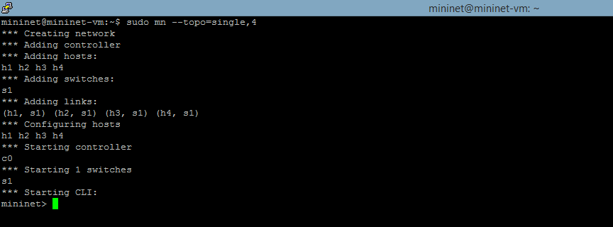

To open the hosts using GUI make sure you have xming running, use xterm h1[h2, h3, h4] to open the hosts

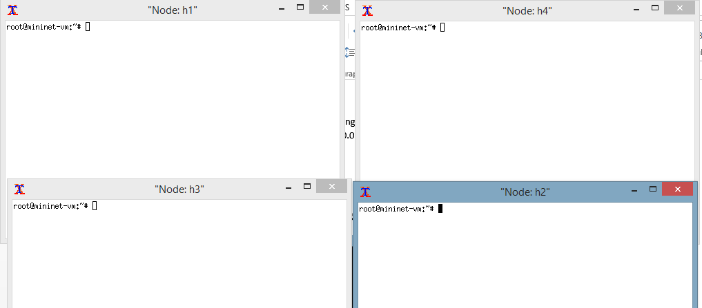

In Server.py

Plug in the server IP and Port

In Peer1, Peer1.py

Plug in Peer1 IP, Server IP, Server Port and Peer port [80 for HTTP]

In Peer2, Pee2.py

Plug in Peer2 IP, Server IP, Server Port and Peer port [80 for HTTP]

In Peer3, Peer3.py

Plug in Peer3 IP, Server IP, Server Port and Peer port [80 for HTTP]

Inorder to the run the scripts use the following command:

Python <file>.py

NOTE:

Make sure you have the necessary text files present in the respective peer paths